Borehole No. Exploration Borehole No 2
Location APDO Tease, Afram Plains
Latitude N06°56.121’
Longitude W00°14.997’
Date started 01/05/2001
Date completed 03/05/2001
Altitude about 860 ft (262.1m) – about 610ft (185.9m) above lake level

Summary Lithological Log
Depth(m)
From To

0 2 Soil/laterite
2 4.1 Soft silty sandy clay
4.1 7.1 Soft sandy clayey silt
7.1 18.3 Soft fine sandy silty clay
18.3 30.5 Soft to very weathered sandy clayey silt
30.5 34.5 Weathered medium grained sandstone with quartz pebbles
34.5 39.6 Very to fairly weathered medium grained sandstone with gravel
39.6 55.9 Fairly weathered medium grained sandstone
55.9 75.2 Fairly weathered medium grained sandstone with gravel bands
75.2 82.3 Fairly weathered medium grained sandstone
82.3 86.4 Slightly weathered to fairly hard siltstone
86.4 90.4 Fairly hard shale and fine grained sandstone
90.4 103.6 Fairly hard fine grained sandstone
103.6 107.7 Fairly hard very fine grained sandstone to siltstone
107.7 111.8 Fairly hard fine grained sandstone to siltstone
111.8 125 Fairly hard siltstone to mudstone
125 131.1 Fairly hard siltstone to very fine grained sandstone
131.1 133.1 Fairly hard very fine grained sandstone
133.1 141.2 Fairly hard very fine grained sandstone to siltstone
141.3 143.3 Fairly hard very fine grained sandstone
143.3 150.4 Fairly hard very fine grained sandstone to siltstone
150.4 152.4 Fairly hard siltstone

Comments on Water Production Zones
First water struck is a small amount of water (16 l/min) at 45m in fairly weathered sandstones just below the base of the very weathered zone.
Flow rate diminishes to 10 l/min by 74m due to smearing of borehole sides with fine sand
Fracture zone marked by calcite veining at 90-91m produced 20 l/min increased to 60 l/min by 92 with increased submergence.
Veining at 98-99m but no obvious increase in flow
Veining at 106m with increase in flow to 92 l/min by 108m
Veining at 111m
Flow rate decreased to 85 l/min by 116m due to borehole smearing
Flow rate increased to 130 l/min by 136 but no apparent inflow zone, some calcite between 134-136m
Even though this borehole was drilled to 152.4m it is not deep enough to be affected by water inflow from the lake.

Detailed Lithological Log

Depth(m)
From To

Soil/laterite
0.0 1.0 5YR 4/6 yellowish red sandy clayey lateritic topsoil.
1.0 2.0 5YR 4/6 yellowish red sandy very clayey lateritic topsoil.

Soft silty sandy clay
2.0 3.0 5YR 4/6 yellowish red and some 2.5YR 4/8 red sandy silty clay.
3.0 4.1 2.5YR 3/6 dark red silty sandy clay. (Dark red brown, orange yellow, ochre
and white soft very weathered sandstone/ferrecrete with some clay)

Soft sandy clayey silt
4.1 5.1 5YR 4/6 yellowish red silty sand with 10YR 6/8 brownish yellow and
10YR 7/2 light grey clay.
5.1 6.1 7.5YR 4/6 strong brown sandy clayey silt.
6.1 7.1 7.5YR 5/6 strong brown sandy clayey silt with some weathered dark red
medium sandstone.

Soft fine sandy silty clay
7.1 8.1 7.5YR 6/6 reddish yellow with 5YR 4/6 yellowish red and 7.5YR 7/1
light grey silty clay.
8.1 9.1 7.5YR 6/6 reddish yellow with 7.5YR 7/1 light grey and a little 5YR 4/6
yellowish red silty clay.
9.1 10.2 5YR 5/6 yellowish red with some 10YR 6/8 brownish yellow sandy silty
clay.
10.2 11.2 2.5YR 5/6 reddish Brown with gley 1 8/1 light greenish grey sandy silty
clay.
11.2 12.2 2.5YR 5/6 reddish brown with gley 1 8/1 light greenish grey sandy silty
clay.
12.2 13.2 2.5YR 5/4 reddish brown with some 2.5YR 8/2 pinkish white silty sandy
clay.
13.2 14.2 2.5YR 5/6 red fine sandy clayey silt. Some 5YR 3/2 dark reddish brown
silty clay.
14.2 15.2 2.5YR 5/6 red fine sandy clayey silt.
15.2 16.3 2.5YR 5/4 reddish brown fine sandy silty clay.
16.3 17.3 2.5YR 5/4 reddish brown fine sandy silty clay.
17.3 18.3 2.5YR 5/4 reddish brown with some 2.5YR 4/3 reddish brown silty clay.
Soft to very weathered sandy clayey silt
18.3 19.3 2.5YR 6/4 light reddish brown fine sandy clayey silt.
19.3 20.3 2.5YR 5/4 reddish brown clayey silt. Some fine sand.
20.3 21.3 2.5YR 6/4 light Reddish Brown clayey silt. Some fine sand.
21.3 22.4 2.5YR 5/6 red sandy clayey silt.
22.4 23.4 2.5YR 4/4 reddish brown sandy clayey silt.
23.4 24.4 2.5YR 5/6 red sandy clayey silt with a very little very highly weathered dark
red sandstone, which has numerous fine dark grains apparent when wet.
(Grey red clayey sandy siltstone, very soft)
24.4 25.4 2.5YR 5/4 reddish brown clayey sandy silt with some very highly weathered
dark red sandstone.
25.4 26.4 2.5YR 5/3 reddish brown sandy clayey silt with very highly weathered light
grey and dark brown sandstone.
26.4 27.4 2.5YR 5/6 red sandy clayey silt with very highly weathered light grey and
dark brown sandstone.
27.4 28.4 2.5YR 5/6 red sandy clayey silt with very highly weathered light grey and
dark brown sandstone.
28.4 29.5 2.5YR 5/4 reddish brown clayey sandy silt with some highly weathered dark
brown medium sandstone.
29.5 30.5 2.5YR 6/4 light reddish brown clayey sandy silt with some highly
weathered dark brown and pale grey medium sandstone.

Weathered medium grained sandstone with quartz pebbles
30.5 31.5 Fairly weathered dark red, light grey and yellow medium sandstone.
31.5 32.5 Fairly weathered dark red, light grey and yellow medium sandstone, with
some quartz and broken rounded pebbles.
32.5 33.5 Mainly dark red with some yellow and light grey medium fairly weathered
sandstone with broken rounded quartz pebbles. (Red and white conglomerate
with much white quartz and brown white fine to medium quartzite very hard,
some hard grey mendium sandstone, odd black/brown ferrecrete nodules with
red clayey to fine sand soft matrix. Some angular brown starined white vein
quartz fragments)
33.5 34.5 Mostly broken rounded quartz and feldspar (?) pebbles with some weathered
dark red and yellow sandstone. (broken conglomerate?)
Very to fairly weathered medium grained sandstone with gravel
34.5 35.6 Weathered dark grey with some red medium sandstone. Some quartz.
35.6 36.6 Very weathered dark grey with some dark red medium sandstone. Some
quartz and an opaque red mineral. (jasper?)
36.6 37.6 Fairly weathered dark grey with some dark red medium sandstone.
37.6 38.6 Medium fairly weathered dark red and dark grey sandstone with some fine
dark grey sandstone.
38.6 39.6 Mostly dark red with some dark grey very weathered medium sandstone.
Some jasper, rounded larger quartz grains and fine grained dark red
sandstone or siltstone. (Dark red brown fine to medium fairly soft friable
sandstone with some black MnO2 cement)
Fairly weathered medium grained sandstone
39.6 40.6 Fairly weathered dark grey with some dark red sandstone. Some dark red
siltstone.
40.6 41.7 Fairly weathered dark grey and red medium sandstone. A little dark red
siltstone.
41.7 42.7 Very weathered dark red and dark grey with a little light grey medium
sandstone. Some fine grained dark red sandstone.
42.7 43.7 Fairly weathered dark red and light grey medium sandstone. Some dark
yellow mineralisation on the red sandstone partings.
43.7 44.7 Mostly dark red fairly weathered medium and fine grained sandstone with
some fairly weathered medium light grey sandstone.
44.7 45.7 Mostly dark red fairly weathered medium sandstone. A little vein quartz.
(Interbedded soft red brown clayey fine to medium sandstone and fairly hard
platey dark brown fine to medium sandstone with some black MnO2 cement)
45.7 46.7 Dark red fairly weathered medium sandstone. A little calcite on partings.
(FRACTURE – 16 L/MIN)
46.7 47.8 Slightly weathered dark red medium sandstone with clear and opaque quartz
and some jasper. Some pale yellow mineral.
47.8 48.8 Fairly weathered dark red medium sandstone with some grains of a yellow
mineral. (feldspar?)
48.8 49.8 Fairly weathered dark red with a little grey medium sandstone.
(Flow – 16 l/min)
49.8 50.8 Fairly weathered dark red with some grey medium sandstone. A little jasper.
50.8 51.8 Fairly weathered dark red with some grey medium sandstone.
51.8 52.8 Fairly weathered dark red medium sandstone.
52.8 53.8 Quite highly weathered dark red medium sandstone.
53.8 54.9 Quite highly weathered dark red medium sandstone with some weathered
grey rounded siltstone.
54.9 55.9 Dark red medium to coarse grained fairly weathered sandstone. Some quartz
fragments and some opaque yellow and pink feldspar. (feldspar?)
(Flow – 14 l/min)
Fairly weathered medium grained sandstone with gravel bands
55.9 56.9 Moderately weathered dark red medium sandstone with some light grey
medium sandstone and some jasper. (Fairly soft weathered silty fine to
medium sandstone with some coarse sand, friable with odd fragment of white
vein quartz)
56.9 57.9 Moderately weathered dark red medium sandstone with some light grey
medium sandstone and some jasper, and a little vein quartz.
57.9 58.9 Mostly slightly weathered dark red medium sandstone with some vein quartz
and some feldspar.
58.9 59.9 Moderately weathered dark red medium sandstone with a little grey medium
to fine sandstone.
59.9 61.0 Fairly weathered dark red medium sandstone. A little quartz and feldspar.
(Flow – 13 l/min)
61.0 62.0 Fairly weathered dark red medium sandstone with some quartz, jasper and
feldspar and a little grey siltstone.
62.0 63.0 Fairly weathered dark red medium sandstone with a few inclusions of dark
grey shale or siltstone.
63.0 64.0 Fairly weathered dark red medium sandstone with a little fine grained grey
sandstone and feldspar.
64.0 65.0 Fairly weathered dark red medium sandstone with a little jasper and some
dark grey siltstone.
65.0 66.0 Fairly weathered dark red medium sandstone.
66.0 67.1 Fairly weathered dark grey with some dark red medium sandstone. A little
quartz and feldspar.
67.1 68.1 Fairly weathered dark grey medium sandstone with a little quartz, jasper and
feldspar. (Flow – 11 l/min)
68.1 69.1 Mostly dark grey with some dark red fairly weathered medium sandstone.
69.1 70.1 Dark grey fairly weathered medium sandstone with some quartz, jasper and a
green mineral. (feldspar?)
70.1 71.1 Dark grey fairly weathered medium sandstone with the odd speckle of red
jasper. A little dark grey fine siltstone.
71.1 72.1 Slightly weathered dark grey medium to coarse sandstone with a little red
jasper.
72.1 73.2 Fairly weathered dark grey with some dark reddish grey medium sandstone.
A little quartz and jasper.
73.2 74.2 Mostly dark grey with a little dark red fairly weathered medium sandstone.
A little quartz and jasper, and a little dark grey siltstone. (Flow – 10 l/min)
74.2 75.2 Mostly dark grey with a little dark red fairly weathered medium sandstone.
A little quartz and jasper, and a little dark grey siltstone. (Dark grey silty fine
to coarse sandstone soft and friable to fairly hard and blocky)
Fairly weathered medium grained sandstone
75.2 76.2 Fairly weathered dark grey medium sandstone.
76.2 77.2 Dark grey with a little dark greyish red fairly weathered medium sandstone
with a little green feldspar.
77.2 78.2 Dark grey with a little dark greyish red fairly weathered medium sandstone
with tiny fragments of jasper and quartz.
78.2 79.2 Dark grey with some dark red slightly weathered medium sandstone with
jasper, clear and opaque quartz and feldspar.
79.2 80.3 Slightly weathered dark grey with some dark red medium sandstone.
(Flow – 10 l/min)
80.3 81.3 Slightly weathered dark grey medium sandstone with some jasper.
81.3 82.3 Fairly weathered dark grey medium sandstone with some jasper and some
yellow and green feldspar. (Dark grey fairly hard friable silty fine sandstone
with white quartz coarse sand and gravel)
Slightly weathered to fairly hard siltstone
82.3 83.3 Uniform slightly weathered dark bluish grey siltstone. (shale?) (Fairly hard
to hard dark grey fairly micaceous intebedded blocky siltstone and fine
sandstone)
83.3 84.3 Uniform slightly weathered dark bluish grey siltstone, with some slatey
partings. Some slightly weathered fine grained dark bluish grey sandstone.
84.3 85.3 Dark bluish grey competent uniform siltstone. (shale?)
85.3 86.4 Dark bluish grey competent uniform siltstone. (shale? Silty tooth but shaley
partings) (Flow – 10 l/min)
Fairly hard shale and fine grained sandstone
86.4 87.4 Dark bluish grey competent uniform shale. A few speckles of mica. (Dark
green grey fairly micaceous fairly soft to fairly hard blocky to platey fine
sandstone)
87.4 88.4 Dark bluish grey competent uniform shale and fine sandstone. More
numerous mica speckles.
88.4 89.4 Dark bluish grey competent uniform shale and fine sandstone. More
numerous mica speckles.
89.4 90.4 Competent fine grained dark grey sandstone with some siltstone. Calcite
mineralisation on partings. Speckles of mica. Some vein quartz. (Dark grey
platey to blocky fairly soft to hard silty fine to medium sandstone some white
calcite veining)
Fairly hard fine grained sandstone
90.4 91.4 Dark bluish grey competent fine grained sandstone. Speckles of a white
mineral (mica?). Some calcite on fractured cleavage surfaces. (Calcite
tested with acid.) (FRACTURE – 20 L/MIN)
91.4 92.5 Dark bluish grey competent shale (or siltstone) with some interlaminated fine
grey sandstone. (Flow – 20 l/min)
92.5 93.5 Dark bluish grey competent fine grained sandstone with some dark bluish
grey shale. Speckles of mica. (FRACTURE – 60 L/MIN)
93.5 94.5 Dark bluish grey competent fine grained sandstone. Speckles of mica. Some
finer (shaley) laminae. (Flow – 60 l/min)
94.5 95.5 Dark bluish grey competent fine grained sandstone. Speckles of mica. Some
finer (shaley) laminae.
95.5 96.5 Dark bluish grey competent fine grained sandstone with some interlaminated
shale. A little calcite. White speckles of mica. (Or is it calcite?)
96.5 97.5 Dark bluish grey competent fine grained sandstone with some white
speckles. A little dark bluish grey shale. A little calcite on partings. A very
little quartz and jasper.
97.5 98.6 Dark bluish grey competent fine grained sandstone. Numerous pieces of
clear vein quartz, including some crystals growing on fracture surfaces. A
smaller amount of finer grained shale. (Dark grey platey fairly hard silty fine
sandstone with some white calcite veining) (Flow – 60 l/min)
98.6 99.6 Dark bluish grey competent fine grained sandstone. Calcite on some
partings. White speckles. (calcite?) A very few reddish bands. (Dark grey
platey fairly hard silty fine sandstone with some white calcite veining).
99.6 100.6 Dark bluish grey competent fine grained sandstone. A very little calcite on
some partings. White speckles. (calcite?) A very few reddish bands.
100.6 101.6 Dark bluish grey competent fine grained sandstone. Some finer, shaley
laminae.
101.6 102.6 Dark bluish grey competent fine grained sandstone. Some finer, shaley
laminae.
102.6 103.6 Dark bluish grey competent fine grained sandstone. Reddish discolouration
on some laminae. Calcite on some cleavage/joint planes. A little dark bluish
grey competent fine grained sandstone.
Fairly hard very fine grained sandstone to siltstone
103.6 104.6 Dark bluish grey competent very fine grained sandstone. (Flow – 60 l/min)
104.6 105.7 Dark bluish grey competent siltstone.
105.7 106.7 Dark bluish grey competent siltstone with some very fine grained sandstone.
Some calcite on joint surfaces. Cleavage slatey in places. Very many tiny
speckles (mica?) apparent when dry.
106.7 107.7 Dark bluish grey competent very fine grained sandstone. Speckles of white
calcite. A little finer grained siltstone.
Fairly hard fine grained sandstone to siltstone
107.7 108.7 Dark bluish grey competent sandstone and siltstone. Flat, finer grained
cleavage planes in places. Calcite speckles. (FRACTURE – 92 L/MIN)
108.7 109.7 Dark bluish grey competent siltstone, slatey cleavage. (i.e. tends to break
along flat surfaces)
109.7 110.7 Dark bluish grey competent fine grained sandstone and siltstone. Calcite
speckles. (Flow – 92 l/min)
110.7 111.8 Dark bluish grey competent fine grained sandstone and siltstone. Calcite
speckles. A very little vein quartz.

Fairly hard siltstone to mudstone
111.8 112.8 Dark bluish grey competent siltstone. Some calcite and some reddish
(weathered?) layers.
112.8 113.8 Dark bluish grey competent siltstone with some very fine grained sandstone
and some mudstone. Calcite speckles. Laminar or slatey cleavage in the
finer grained material.
113.8 114.8 Dark bluish grey competent siltstone with some slatey partings.
114.8 115.8 Dark bluish grey very fine grained sandstone and siltstone.
115.8 116.8 Dark bluish grey competent siltstone with some very fine grained sandstone.
(Flow – 85 l/min)
116.8 117.9 Dark bluish grey competent siltstone.
117.9 118.9 Dark bluish grey competent siltstone with a little (finer grained) mudstone.
118.9 119.9 Dark bluish grey competent siltstone with a little (finer grained) mudstone.
119.9 120.9 Dark bluish grey competent siltstone with a little calcite.
120.9 121.9 Dark bluish grey competent siltstone and mudstone/shale. "Frosting" due to
calcite in places.
121.9 122.9 Dark bluish grey competent siltstone.
122.9 124.0 Dark bluish grey competent siltstone with some mudstone/shale.
124.0 125.0 Dark bluish grey competent siltstone with some calcite and a little reddish
discolouration or mineralisation in places.
Fairly hard siltstone to very fine grained sandstone
125.0 126.0 Dark bluish grey competent siltstone with some very fine grained sandstone.
Some calcite "frosting" and some red discolouration.
126.0 127.0 Dark bluish grey competent siltstone with some very fine grained sandstone.
127.0 128.0 Dark bluish grey competent siltstone with some very fine grained sandstone.
128.0 129.0 Dark bluish grey competent siltstone with some very fine grained sandstone.
(Flow – 85 l/min)
129.0 130.0 Dark bluish grey competent siltstone with some very fine grained sandstone
with a little calcite and some red discolouration.
130.0 131.1 Dark bluish grey competent siltstone with some very fine grained sandstone
with a little calcite and some red discolouration.
Fairly hard very fine grained sandstone
131.1 132.1 Dark bluish grey competent very fine grained sandstone and siltstone with
some calcite frosting and shaley partings
132.1 133.1 Dark bluish grey competent very fine grained sandstone (dark grey to black
hard amorphous silty fine sandstone)
Fairly hard very fine grained sandstone to siltstone
133.1 134.1 Dark bluish grey competent siltstone, mica speckles apparent when dry, is
light grey when dry (Flow – 85 l/min)
134.1 135.1 Dark bluish grey (light grey when dry) very fine grained competent
sandstone to siltstone, massive rather than platey cleavage, calcite frosting,
mica speckles when dry
135.1 136.1 Dark bluish grey (light grey when dry) very fine grained competent
sandstone to siltstone, some platey cleavage, calcite frosting, mica speckles
when dry (FRACTURE – 130 L/MIN)
136.1 137.2 Dark bluish grey fairly competent to competent very fine grained sandstone
and shale, some platey partings with speckles of calcite and some mica
137.2 138.2 Dark bluish grey competent very fine grained sandstone to siltstone, some
shaley partings, calcite and some mica
138.2 139.2 Dark bluish grey competent very fine grained sandstone to siltstone, some
shaley partings, calcite and some mica
139.2 140.2 Dark bluish grey competent very fine grained sandstone to siltstone, some
calcite frosting sometimes in bands, much small micas
140.2 141.2 Dark bluish grey hard competent very fine grained sandstone to siltstone,
some calcite frosting, massive in parts, otherwise platey
(Flow – 130 l/min)
Fairly hard very fine grained sandstone
141.2 142.2 Dark bluish grey competent very fine grained sandstone, some calcite
discolouration (frosting), many speckles of mica (Dark green grey to black
fairly hard to hard silty fine sandstone)
142.2 143.3 Dark bluish grey competent very fine grained sandstone, some calcite
discolouration (frosting), many speckles of mica
Fairly hard very fine grained sandstone to siltstone
143.3 144.3 Dark bluish grey competent siltstone, sometimes massive or shaley/platey,
some dark red discolouration, calcite frosting and mica speckles
144.3 145.3 Dark bluish grey competent very fine grained sandstone,, some calcite
frosting and dark red discolouration
145.3 146.3 Dark bluish grey competent very fine grained sandstone to siltstone, some
calcite and mica speckles (Flow – 130 l/min)
146.3 147.3 Dark bluish grey competent very fine grained sandstone to siltstone, mica
speckles, some cloudy calcite, mainly massive
147.3 148.3 Dark bluish grey competent very fine grained sandstone to siltstone, mica
speckles, some cloudy calcite, mainly massive
148.3 149.4 Dark bluish grey competent very fine grained sandstone to siltstone, some
calcite frosting and mica speckles (Dark grey black fairly hard to hard silty
fine sandstone)
149.4 150.4 Dark bluish grey competent very fine grained sandstone, slightly coarser,
some calcite and red discolouration with mica speckles

Fairly hard siltstone
150.4 151.4 Dark bluish grey competent siltstone, a little calcite in spots, some mica
speckles
151.4 152.4 Dark bluish grey competent siltstone, a little calcite in spots, some mica
speckles (Dark grey black very hard quartzitic silty fine sandstone)
(Flow – 130 l/min)

Ghana |  | Test pumping |  |  | Point above GL |  |  | 0.4 | m
Borehole No. |  | TH002 |  |  | Pump depth |  |  | 80 | m
Village |  | Tease APDO |  |  | SWL |  |  | 34.74 | m
Date |  | 05/05/2001 |  |  | Start Time |  |  | 05:30
Drawdown test |  |  |  |  | Recovery test
t (mins) | wl (m) | s (m) | q (l/min) | Sp cap | t | t' | t/t' | wl (m) | s' (m)
0 | 34.74 |  |  |  | 480 | 0 |  | 58 | 23.26
1 | 37.93 | 3.19 | 142 | 44.51 | 481 | 1 | 481.00 | 54.53 | 19.79
2 | 39.46 | 4.72 | 142 | 30.08 | 482 | 2 | 241.00 | 53.03 | 18.29
3 | 40.2 | 5.46 | 142 | 26.01 | 483 | 3 | 161.00 | 52.51 | 17.77
4 | 40.64 | 5.9 | 142 | 24.07 | 484 | 4 | 121.00 | 52.13 | 17.39
5 | 41.08 | 6.34 | 142 | 22.40 | 485 | 5 | 97.00 | 51.91 | 17.17
6 | 41.47 | 6.73 | 142 | 21.10 | 486 | 6 | 81.00 | 51.7 | 16.96
7 | 41.63 | 6.89 | 142 | 20.61 | 487 | 7 | 69.57 | 51.56 | 16.82
8 | 41.9 | 7.16 | 142 | 19.83 | 488 | 8 | 61.00 | 51.45 | 16.71
9 | 42.02 | 7.28 | 142 | 19.51 | 489 | 9 | 54.33 | 51.36 | 16.62
10 | 42.16 | 7.42 | 142 | 19.14 | 490 | 10 | 49.00 | 51.27 | 16.53
15 | 42.74 | 8 | 142 | 17.75 | 495 | 15 | 33.00 | 50.94 | 16.2
20 | 43.2 | 8.46 | 142 | 16.78 | 500 | 20 | 25.00 | 50.63 | 15.89
25 | 43.63 | 8.89 | 142 | 15.97 | 505 | 25 | 20.20 | 50.39 | 15.65
30 | 44.01 | 9.27 | 142 | 15.32 | 510 | 30 | 17.00 | 50.16 | 15.42
35 | 44.34 | 9.6 | 142 | 14.79 | 515 | 35 | 14.71 | 49.95 | 15.21
40 | 44.67 | 9.93 | 142 | 14.30 | 520 | 40 | 13.00 | 49.75 | 15.01
45 | 45 | 10.26 | 142 | 13.84 | 525 | 45 | 11.67 | 49.57 | 14.83
50 | 45.3 | 10.56 | 142 | 13.45 | 530 | 50 | 10.60 | 49.39 | 14.65
55 | 45.6 | 10.86 | 142 | 13.08 | 535 | 55 | 9.73 | 49.23 | 14.49
60 | 45.87 | 11.13 | 142 | 12.76 | 540 | 60 | 9.00 | 49 | 14.26
75 | 46.64 | 11.9 | 142 | 11.93 | 555 | 75 | 7.40 | 48.6 | 13.86
90 | 47.33 | 12.59 | 142 | 11.28 | 570 | 90 | 6.33 | 48.15 | 13.41
105 | 48 | 13.26 | 142 | 10.71 | 585 | 105 | 5.57 | 47.74 | 13
120 | 48.55 | 13.81 | 142 | 10.28 | 600 | 120 | 5.00 | 47.43 | 12.69
135 | 49.07 | 14.33 | 142 | 9.91 | 615 | 135 | 4.56 | 47.13 | 12.39
150 | 49.63 | 14.89 | 142 | 9.54 | 630 | 150 | 4.20 | 46.88 | 12.14
165 | 50.13 | 15.39 | 142 | 9.23 | 645 | 165 | 3.91 | 46.63 | 11.89
180 | 50.63 | 15.89 | 142 | 8.94 | 660 | 180 | 3.67 | 46.4 | 11.66
195 | 51.08 | 16.34 | 142 | 8.69 | 690 | 210 | 3.29 | 46 | 11.26
210 | 51.57 | 16.83 | 142 | 8.44 | 720 | 240 | 3.00 | 45.69 | 10.95
225 | 52.01 | 17.27 | 142 | 8.22
240 | 52.41 | 17.67 | 142 | 8.04
255 | 52.83 | 18.09 | 142 | 7.85
270 | 53.24 | 18.5 | 142 | 7.68
285 | 53.62 | 18.88 | 142 | 7.52
300 | 54.02 | 19.28 | 142 | 7.37
315 | 54.41 | 19.67 | 142 | 7.22
330 | 54.79 | 20.05 | 142 | 7.08
345 | 55.15 | 20.41 | 142 | 6.96
360 | 55.5 | 20.76 | 142 | 6.84
390 | 56.16 | 21.42 | 142 | 6.63
420 | 56.77 | 22.03 | 142 | 6.45
450 | 57.4 | 22.66 | 142 | 6.27
480 | 58 | 23.26 | 142 | 6.10

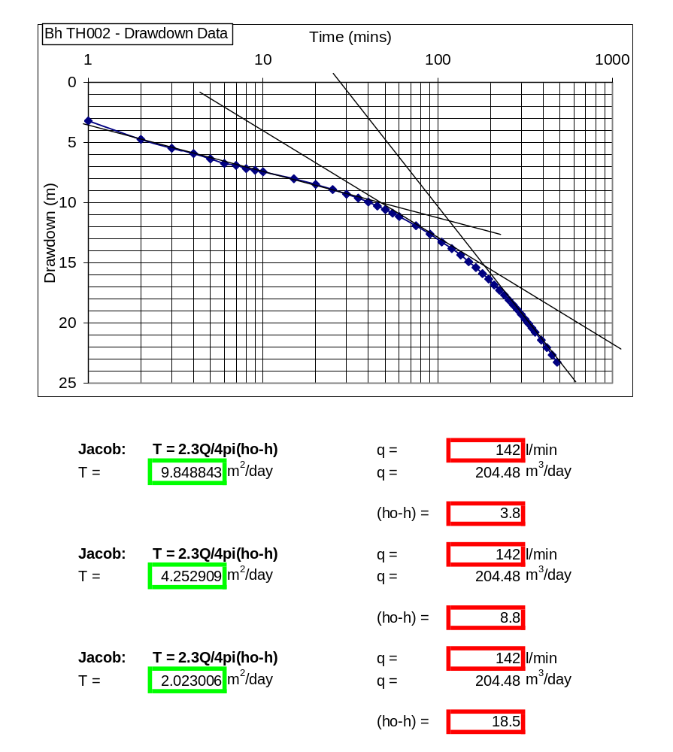

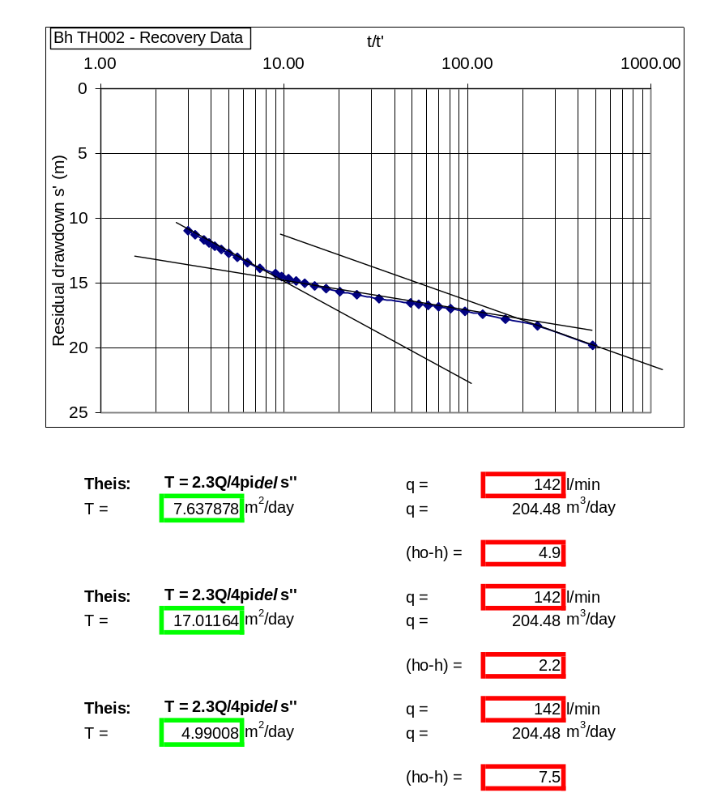

OBSERVATION BOREHOLE |  |  |  |  | Distance to Bh |  | 8.4 | m
Village |  | Tease |  |  | SWL |  | 33.76 | m
Latitude |  | 06deg | 56.142 | N | Start Time |  | 05:30
Longitude |  | 00deg | 15.01 | W | Datum |  | Top of casing
Date |  | 14/05/2001 |  |  | Test type |  | Constant discharge
Drawdown test |  |  |  |  | Recovery Test
time | pwl (m) | dd (m) |  |  | time | wl (m) | dd (m)
0 | 33.76 | 0 |  |  | 0 | 44.63 | 10.87
1 | 33.93 | 0.17 |  |  | 1 | 44.63 | 10.87
2 | 34.05 | 0.29 |  |  | 2 | 44.63 | 10.87
3 | 34.2 | 0.44 |  |  | 3 | 44.63 | 10.87
4 | 34.29 | 0.53 |  |  | 4 | 44.63 | 10.87
5 | 34.55 | 0.79 |  |  | 5 | 44.63 | 10.87
6 | 34.8 | 1.04 |  |  | 6 | 44.63 | 10.87
7 | 35.03 | 1.27 |  |  | 7 | 44.63 | 10.87
8 | 35.28 | 1.52 |  |  | 8 | 44.63 | 10.87
9 | 35.37 | 1.61 |  |  | 9 | 44.63 | 10.87
10 | 35.55 | 1.79 |  |  | 10 | 44.63 | 10.87
15 | 36.4 | 2.64 |  |  | 15 | 44.63 | 10.87
20 | 37.35 | 3.59 |  |  | 20 | 44.63 | 10.87
25 | 38.17 | 4.41 |  |  | 25 | 44.63 | 10.87
30 | 38.63 | 4.87 |  |  | 30 | 44.63 | 10.87
35 | 39.27 | 5.51 |  |  | 35 | 44.63 | 10.87
40 | 39.93 | 6.17 |  |  | 40 | 44.63 | 10.87
45 | 40.4 | 6.64 |  |  | 45 | 44.63 | 10.87
50 | 40.75 | 6.99 |  |  | 50 | 44.63 | 10.87
55 | 41.2 | 7.44 |  |  | 55 | 44.63 | 10.87
60 | 41.73 | 7.97 |  |  | 60 | 44.63 | 10.87
75 | 42.62 | 8.86 |  |  | 75 | 44.63 | 10.87
90 | 43 | 9.24 |  |  | 90 | 44.63 | 10.87
105 | 43.18 | 9.42 |  |  | 105 | 44.63 | 10.87
120 | 43.2 | 9.44 |  |  | 120 | 44.63 | 10.87
135 | 43.23 | 9.47 |  |  | 135 | 44.63 | 10.87
150 | 43.35 | 9.59 |  |  | 150 | 44.63 | 10.87
165 | 43.48 | 9.72 |  |  | 165 | 44.63 | 10.87
180 | 43.5 | 9.74 |  |  | 180 | 44.63 | 10.87
195 | 43.54 | 9.78 |  |  | 195 | 44.59 | 10.83
210 | 43.58 | 9.82 |  |  | 210 | 44.53 | 10.77
225 | 43.61 | 9.85
240 | 43.67 | 9.91
255 | 43.73 | 9.97
270 | 43.8 | 10.04
285 | 43.85 | 10.09
300 | 43.92 | 10.16
315 | 44.01 | 10.25
330 | 44.06 | 10.3
345 | 44.12 | 10.36
360 | 44.18 | 10.42
390 | 44.29 | 10.53
420 | 44.4 | 10.64
450 | 44.5 | 10.74
480 | 44.63 | 10.87

